

SINDH MADRESSATUL ISLAM UNIVERSITY (SMIU) DEPARTMENT OF DATA SCIENCE (DS)

FALL 2026

COURSE TITLE: INTRODUCTION TO DATA SCIENCE
SEMESTER/SECTION: BSDS 4th, BSSE 6th (A, B)
COURSE CODE: CSC 218
INSTRUCTOR: MS. LARAIB WAHEED

Lab 1
Introduction to EDA & Pandas Basics
Objective
- Understand what Exploratory Data Analysis (EDA) is and why it is important in Data Science.
- Learn about key Python libraries for EDA: Pandas, NumPy, Matplotlib, Seaborn.
- Get hands-on with Pandas basics: reading data, exploring rows/columns, and basic info.
- Revise Python fundamentals (variables, lists, dictionaries) where needed.

What is EDA?
The process of analyzing datasets to summarize their main characteristics, often with visual methods. It helps to:
- Detect missing values.
- Understand data types.
- Identify trends, outliers, distributions.
Libraries in EDA:
- Pandas → Data manipulation & analysis.
- NumPy → Numerical operations.
- Matplotlib → Data visualization.
- Seaborn → Statistical data visualization.
Key Steps in EDA:
- Check data shape & columns
- Find missing values
- See summary statistics (mean, median, min, max)
- Create basic visualizations (histogram, bar chart)

Pandas Basics in Detail:
1. Importing Datasets with read_csv()
- Function: pd.read_csv("filename.csv")
- Purpose: Loads data from a CSV/Excel file into Python as a DataFrame (a table of rows and columns).
- Connection with Python Basics:
In Python, we normally read files using open("file.txt"), but Pandas makes it much easier by directly converting the file into a structured dataset.
Example:
import pandas as pd
df = pd.read_csv("students.csv")
print(df)
Exploring Data
a. .head()
- Shows the first 5 rows of the dataset.
- Helps us quickly check if data is loaded correctly.
- Similar to Python slicing mylist[0:5].
Example:
print(df.head())
b. .tail()
- Shows the last 5 rows of the dataset.
- Useful for checking the most recent or last records.
- Similar to mylist[-5:] in Python.
Example:
print(df.tail())
c. .info()
- Displays the structure of the dataset:
  - Column names
  - Data types (integer, float, string)
  - Missing values count
- In Python, we use type() for a single variable; here, .info() gives types for the entire dataset.
Example:
print(df.info())
d. .shape
- Returns the number of rows and columns in the dataset.
- Example: (100, 5) means 100 rows and 5 columns.
- Similar to len(mylist) in Python, but extended for 2D data.
Example:
print(df.shape)
e. .columns
- Lists all column names in the dataset.
- Like dictionary keys in Python (mydict.keys()).
Example:
print(df.columns)

How Python Basics Relate to Pandas
Python Concept | Pandas Equivalent
List slicing → mylist[0:5] | DataFrame → .head()
List slicing → mylist[-5:] | DataFrame → .tail()
len(mylist) | DataFrame → .shape[0] (rows)
Dictionary → mydict.keys() | DataFrame → .columns
type(x) | DataFrame → .info()
File handling → open("file") | Pandas → read_csv()

Task 1:
A College has provided a CSV file of students’ marks. Your task is to:
- Load the dataset into Pandas.
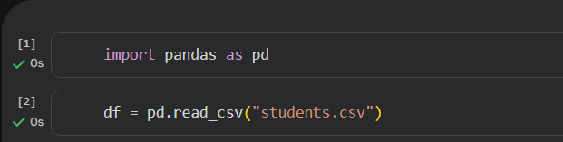
- Explore the first few and last few rows.
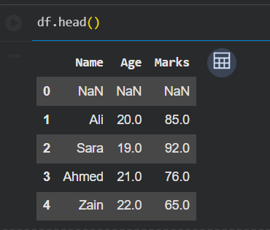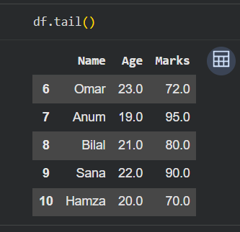
- Check the structure of the dataset (rows, columns, datatypes).
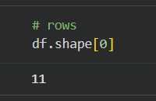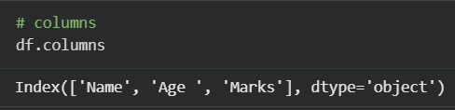
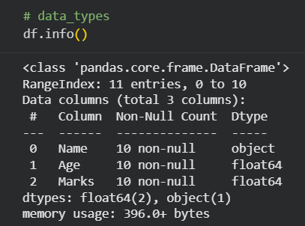

Task 2:
A company has provided a CSV file of Inventory Data Set. Your task is to:
- Load the dataset into Pandas.
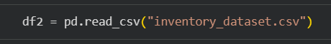
- Explore the first few and last few rows.
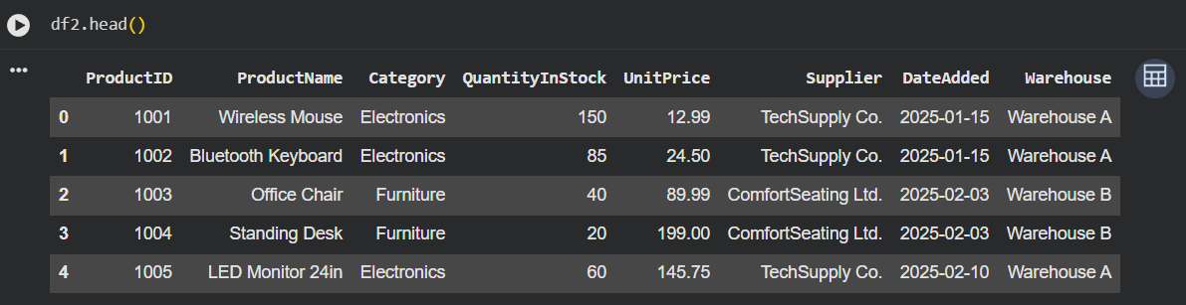
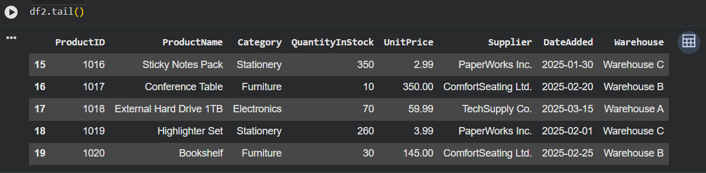
- Check the structure of the dataset (rows, columns, datatypes).
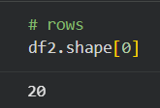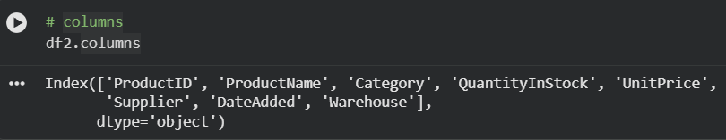
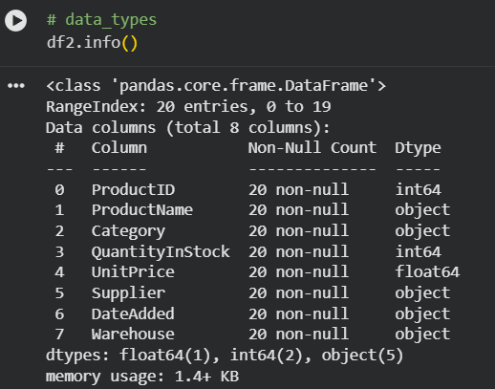
Google colab Link: https://colab.research.google.com/drive/1hYt3QlNLtLKNdGuDiS9jdK37yi2kDRw8?usp=sharing

